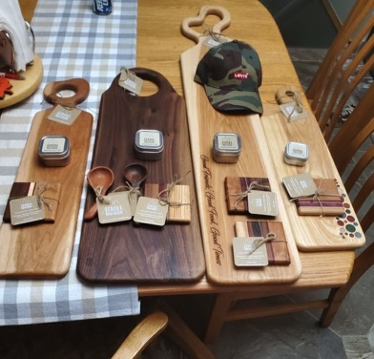
Charcuterie Boards donated by Ron Bochman from Birchcove

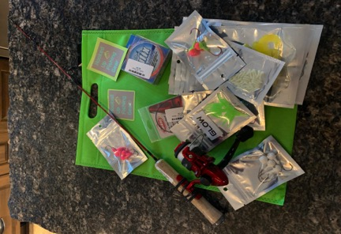
Fishing rod and tackle boxes
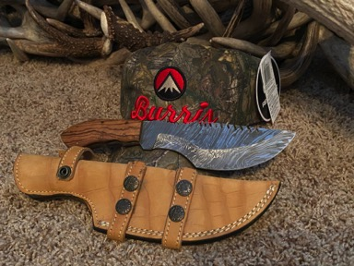
Damascus knife and sheath donated by Mitchell Payments Moment of Truth TV

Ice Fishing Tent donated by Saputo
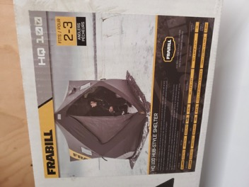
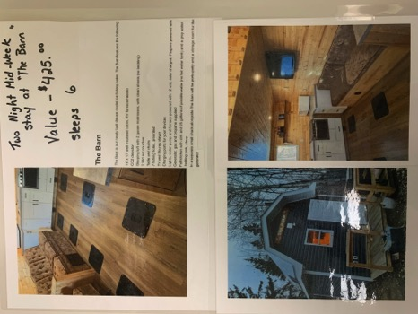

Two night stay in “The Barn” donated by Walter Tomm

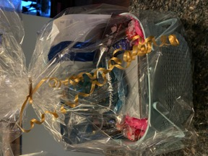
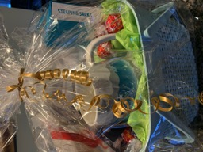

Spaology baskets donated by Arlene Henituik

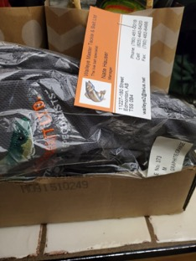
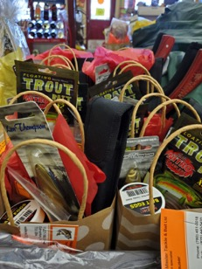

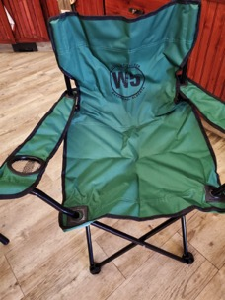
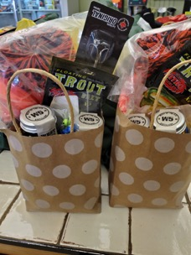
Prize baskets/shirts donated by Walleye Master Tackle and Bait

Chairs and Gift Baskets donated by W5th Distillery

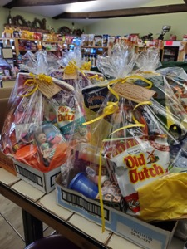
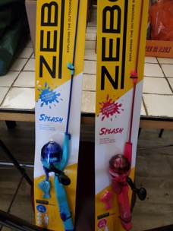
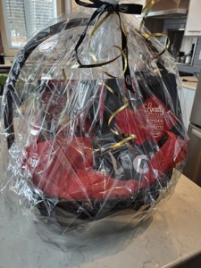
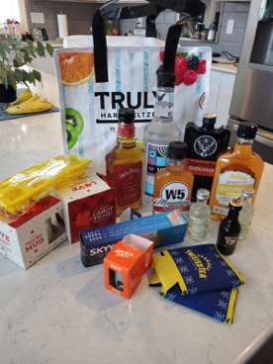
Kids fishing rods and gift baskets donated by the Lac La Nonne General Store

Liquor baskets donated by Pembina West Co-op

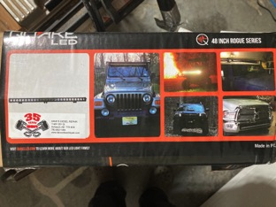
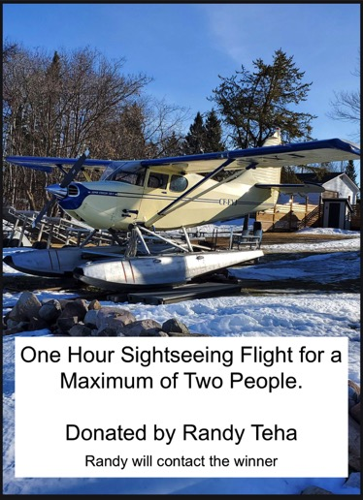
Light Bar donated by Dave’s Diesel Repairs

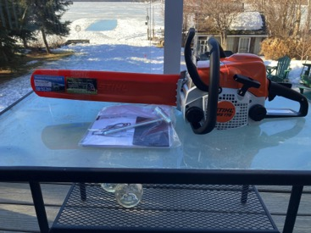
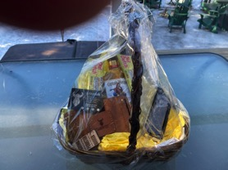
Knife and leather package donated by Rlsth Design

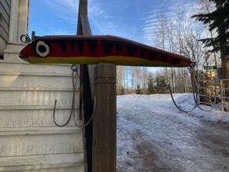
Chainsaw donated by Dentith Vac Truck Service and Small Power

Homemade Giant Fishing Lure donated by Leon Marciak
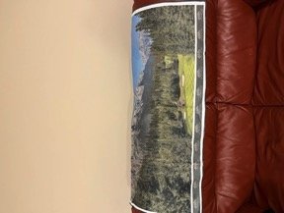
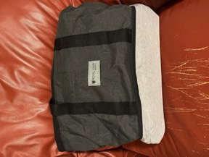
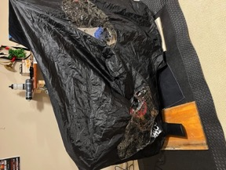

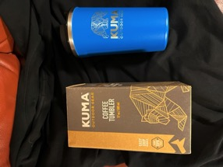
KUMA tumbler, golf towels, coolers, and golf cart cover donated by Royal Camp Catering

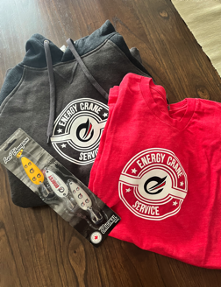
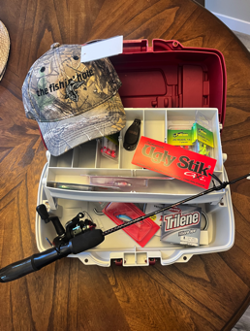
Hoodie, shirt, fishhooks donated by Energy Crane Service
Kids fishing set donated by The Fishin’ Hole

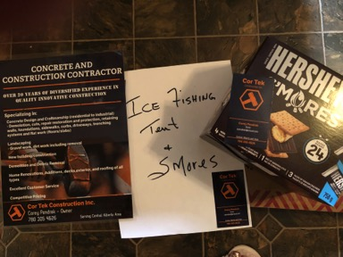

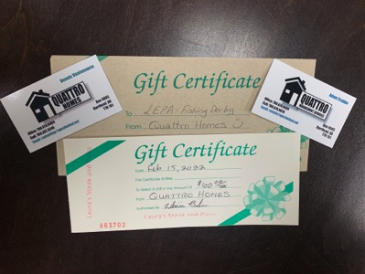
Ice Fishing Tent and S’mores Kit donated by Cor Tek Construction Inc.

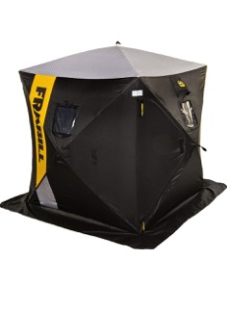
Gift certificate $100 to a local restaurant donated by Quattro Homes

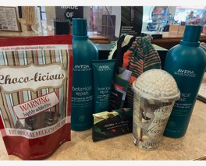

Aveda Hair Package donated Kim Walker

Ice Fishing tent donated
by Gord and Cindy Sample

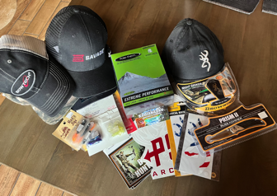
Package donated by Kodiak Lake Hunting and Fishing

